## Exercise 6 – Seasonal Adjustment

Copy and run the following commands to adjust the series *.\data\cr\CR Regional IPC.dat*

**ipc <- import.ts(“***[ directory ]***\\data\\cr\\cr regional ipc.dat”,format=”datevalue”)**

**c <- seas(ipc, outlier.types=”all”, automdl=””, x11 =””, slidingspans=””,regression.aictest=NULL)**

Examine the seasonality of the series. Should it be seasonally adjusted?

There are no seasonal peaks in the spectrum of the original series – not even any not-visually-significant peaks.

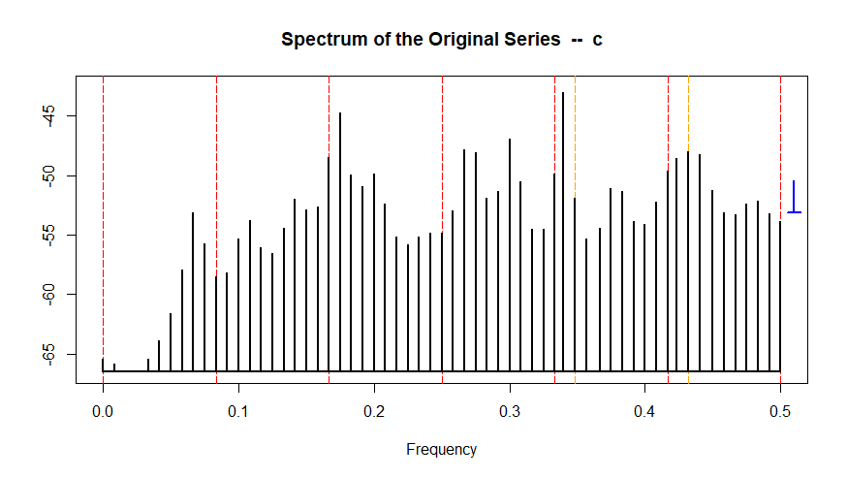

> qs(c)

qs p-val

qsori 13.44784 0.00120

qsorievadj 9.29975 0.00956

qsrsd 0.00000 1.00000

qssadj 0.00000 1.00000

qssadjevadj 0.00000 1.00000

qsirr 0.00000 1.00000

qsirrevadj 0.00000 1.00000

qssori 1.65077 0.43807

qssorievadj 1.65077 0.43807

qssrsd 0.66779 0.71613

qsssadj 0.39115 0.82236

qsssadjevadj 0.00000 1.00000

qssirr 0.00000 1.00000

qssirrevadj 0.00000 1.00000

Coefficients:

Estimate Std. Error z value Pr(>|z|)

Jan 1.407e-03 1.082e-03 1.300 0.194

Feb 1.716e-03 1.078e-03 1.592 0.111

Mar 1.100e-03 1.072e-03 1.026 0.305

Apr 7.154e-04 1.070e-03 0.668 0.504

May -8.507e-05 1.069e-03 -0.080 0.937

Jun 5.093e-04 1.070e-03 0.476 0.634

Jul 1.120e-03 1.072e-03 1.045 0.296

Aug 4.604e-04 1.078e-03 0.427 0.669

Sep -1.374e-03 1.078e-03 -1.274 0.203

Oct -1.670e-03 1.078e-03 -1.549 0.121

Nov -1.718e-03 1.079e-03 -1.592 0.111

TC2017.Jan -1.348e-03 2.342e-03 -0.575 0.565

LS1998.Nov 1.351e-02 2.717e-03 4.974 6.56e-07 ***

LS2004.Jan 1.878e-02 3.010e-03 6.240 4.37e-10 ***

TC2004.Feb 2.262e-02 2.583e-03 8.757 < 2e-16 ***

LS2005.Jan 1.292e-02 2.723e-03 4.745 2.08e-06 ***

AR-Nonseasonal-01 8.903e-01 2.635e-02 33.783 < 2e-16 ***

AR-Seasonal-12 -9.424e-02 5.886e-02 -1.601 0.109

Create a seasonal object called fd.x11 for .\data\retail\fuel dealers.dat. Use the ARIMA model (0 1 1)(0 1 1). Perform an X-11 adjustment.

1. Describe the spectrum of the original series. Use **spectrumgraph(fd.x11, “ori”).**

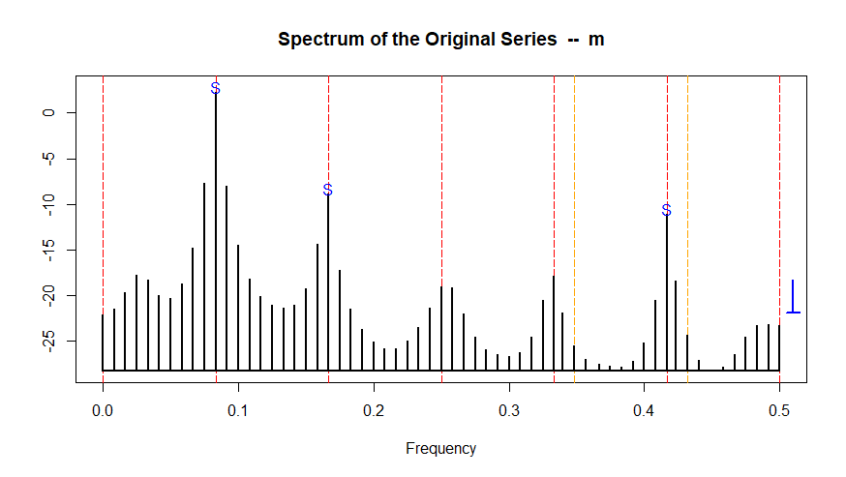

There are visually significant peaks at S1, S2, and S5

1. Look at the spectrum of the seasonally adjusted series, the irregular, and the residuals. (Use the spectrumgraph(seasonal object,component) function in X13Graphs.r, with component “sa”, “irr”, and “rsd” respectively.) Is there evidence of residual seasonality or residual calendar effects?

There are no seasonal peaks in the spectrum of the seasonally adjusted series or the irregular, so there is no residual seasonality. There are no trading day peaks in any spectra, so no residual calendar effects. There is a visually significant seasonal peak at S5 in the spectrum of the residuals and the seasonal peak at S1 is almost significant – 5.5 stars – which may indicate problems modeling the seasonal pattern.

1. The seasonal filter was selected based on the global moving seasonality ratio. What was the GMSR for this series? What seasonal filter was selected?

The GMSR (I/S Ratio) is 3.52, and a 3x5 filter was selected. (Table F 2.H in the output file gives the I/S ratio, and Table D 10 the seasonal filter.)

Re-run the seasonal object with the seasonal filter hard-coded **x11.seasonalma = "s3x5"**, sliding span analysis **slidingspans = “ ”** and the history spec turned on **history = “ ”**.

1. Look at the sliding spans diagnostics. Is this adjustment acceptably stable? Why or why not?

There are 26% months with failing seasonal factors and 22% of months have a failing month-to-month change. This is not acceptably stable, since we would like % failing SF to be below 15% and we really want it below 25%. The month to month changes are okay, as we’d like these to be below 40%.

1. Look in the output file for the history tables. Which months have the largest revisions?

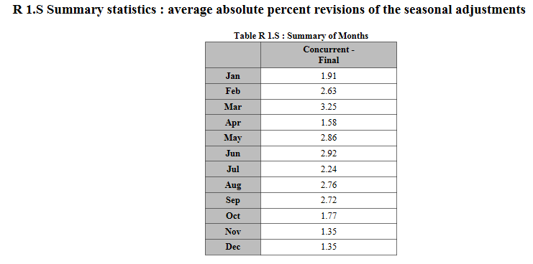

The highest revisions are in March.

1. a) Look at the graph of the Seasonal Factors and SI Ratios by Month (using the sigraph() function in X13Graphs.r), or at Table D9. Which months have the most replaced SI ratios?

February and March both have 8 months with a replaced SI ratio. January and December both have 7 replaced values.

b) Create a new seasonal object called fd.x11sl for the series with the sigma limits raised to (1.8 2.8). Are there fewer replaced SI ratios in the months identified in 6a)?

With the higher limits, January has 4 replacements (down 3), February has 7 (down 1), March has 7 (down 1), and December has 6 (down 1).

Create a new seasonal object called fd.seats, running a default seats adjustment instead of X-11. Keep the airline model and include sliding spans and history.

Create a new seasonal object called fd.seats2, which performs a default seats adjustment and starts the model span in 2004.1. Keep the airline model and include sliding spans and history.fd

1. Compare the regARIMA models from fd.seats and fd.seats2. Which model has better model diagnostics? The full span model has 10 failing LBQ, including lags 12 and 24. It has 3 lags with a significant ACF (but they are at 5, 11, and 23, which are not considered important lags) and a visually significant peak at S5 in the residuals – this is not a peak we generally worry about when the other seasonal frequencies are not peaks, but S1 is almost a visually significant peak (5.5 stars). With the shorter model span, there are no LBQ or ACF failures and no seasonal or trading day peaks in the spectrum of the residuals. But forecasts are a little worse for the short model span series.
2. Compare the sliding spans diagnostics and the revisions from the four adjustments fd.x11, fd.x11sl, fd.seats and fd.seats2. Which adjustment has the greatest stability? Sliding span results are a little better for fd.seats2 then for either of the x11 adjustments. They look best for fd.seats, but the span length is 102 for the other three models and 198 for fd.seats, so this comparison is problematic.

We can compare the average SA and MM revisions in fd.x11, fd.x11sl, and fd.seats because they have the same start date (2000.1). fd.seats has the largest revision in the seasonal adjustment (2.6, compared to 2.3 and 2.2 for the x11 adjustments) but the smallest revision in the month-to-month change (1.67, compared to 1.83 and 1.76).

We can set the history start date to 2009.1 for all four adjustments, and then fd.seats2 has the lowest revisions (2.78 SA and 1.63 MM) while fd.seats has the worst (3.56 SA and 2.05 MM), with the X-11 adjustments in the middle (fd.x11: 3.16 SA and 1.92 MM fd.x11sl: 3.03 SA and 1.77 MM).

1. Create graphs comparing the seasonal adjustments of fd.x11, fd.x11sl, fd.seats, and fd.seats2. Are they similar? Look at overlay graphs of the seasonal factors (use the sfcompgraph() function in X13Graphs.r). Where do you see the biggest differences? The two x11 adjustments are very similar and the two seats adjustments are very similar. The largest differences are between the x11 and the seats adjustments.